Name: ACT 5: Modeling Volcanic Eruptions
Period: Volcano Explorer – Interactive Volcanoes

Getting Started
- To open the VolcanoExplorer website:
  - Go to an internet browser (Firefox, Chrome, etc.)
  - Go to Mr. Groom’s website on the Mt. Tabor website.
  - Go to the SEPUP Earth Science Links and Info page and scroll down to Activity 5, and click on the Volcano Explorer link.

- Find and click “Enter” 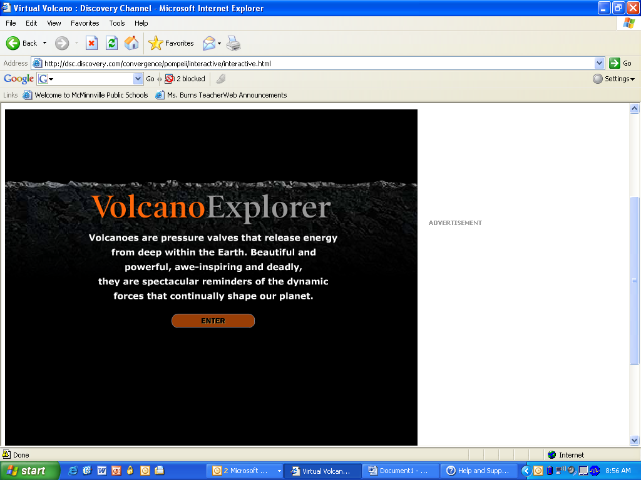

- You now see a rotating globe with a symbol key next to it. The symbols represent geological features.

  - What geological feature do the red triangles represent? ____________________
  - What geological feature do the white lines represent? ______________________

- Use the “Stop rotation” 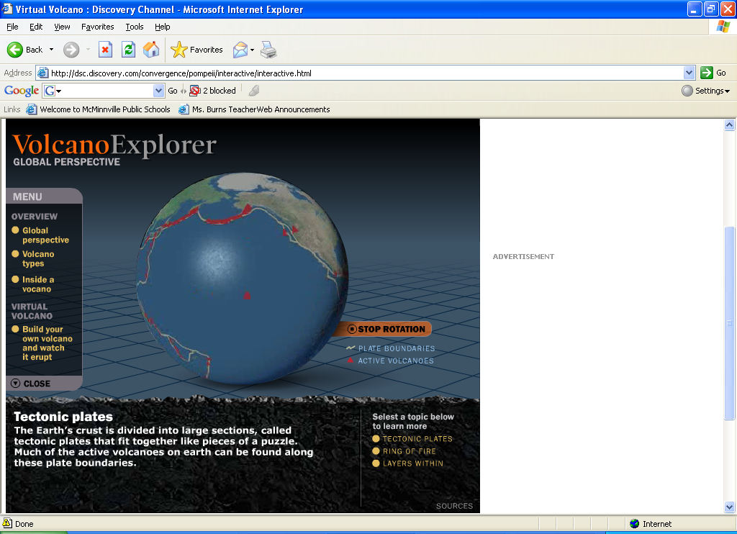 button to stop and start the rotation of the Earth. Where are some places you see many volcanoes? (Such as what countries, continents, or oceans) ______________________________________________________________________________________________________________________________________________________

- What other geological feature is commonly seen at the same locations as volcanoes? ___________________________________________________________________________
- Why do you think volcanoes and plate boundaries are in the same places? ______________________________________________________________________________________________________________________________________________________
Types of Volcanoes
- Now we are going to explore the three main types of volcanoes. On the left menu click on volcano types. A new screen appears.

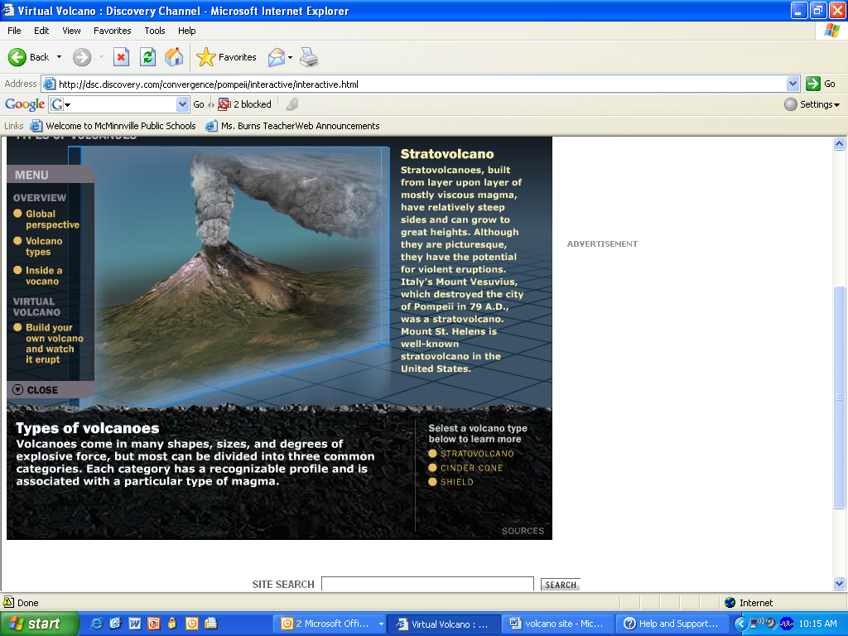
- To look at the different volcano types,
click on their names in the lower right corner.

- Fill in the back of this sheet to compare the three types of volcanoes. Draw each volcano in the empty box and fill in the information box.

Type of Volcano: STRATOVOLCANO
Short or tall:
Made of/Built of:

Description of shape:

Example:
Type of Volcano: SHIELD VOLCANO
Short or tall:
Made of/Built of:

Description of shape:

Example:

Type of Volcano: CINDER CONE VOLCANO
Short or tall:
Made of/Built of:

Description of shape:

Example:

What’s on the inside of a volcano?

- Click on “Inside a Volcano” (on the left menu)

- Use the diagram on the screen to fill in the diagram of the inside of a volcano below.
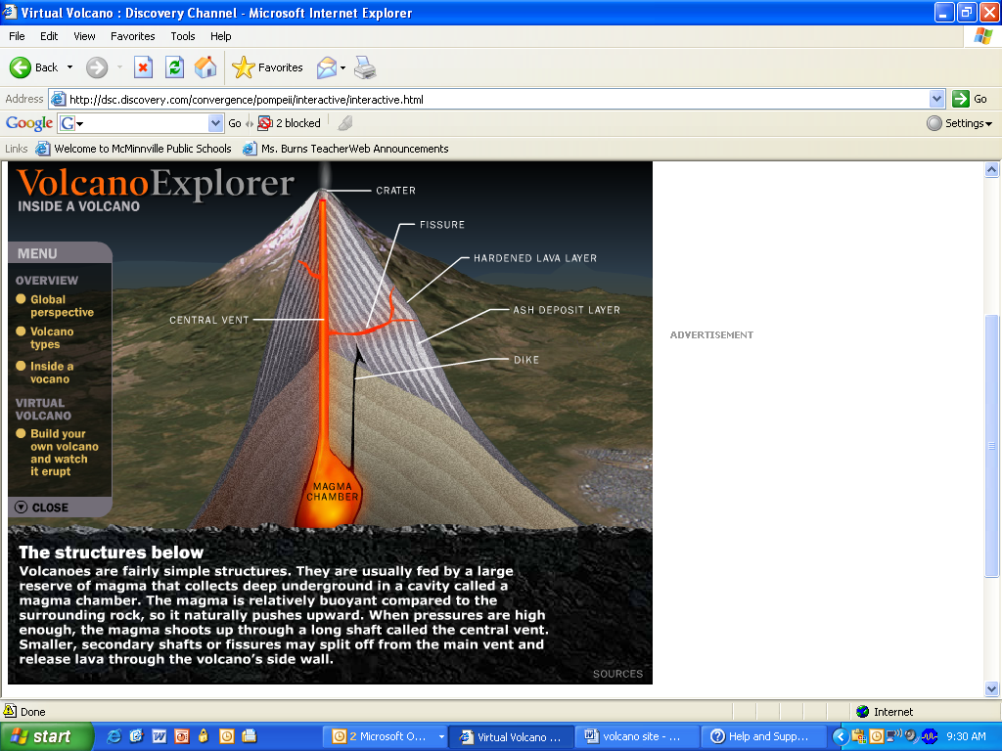

How does viscosity affect eruptions?
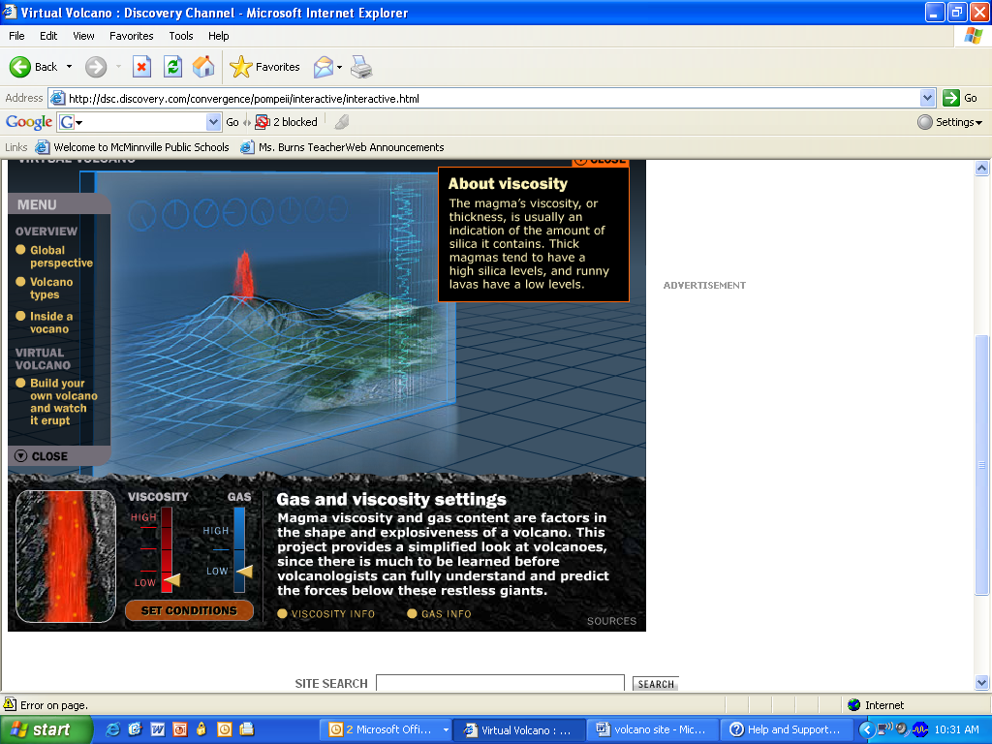
- Now click on “Build your own volcano” on the left side menu.

- A volcano is affected by the viscosity and gas content of its magma. Click on the “Viscosity Info” button at the bottom. A small box will pop-up near the volcano. Read the information to answer:

  - What is viscosity?
  - What makes lava viscous?

- Change the viscosity to see how it affects the magma. To do this, move the viscosity arrow up and down. Look at the box of moving magma on the left.
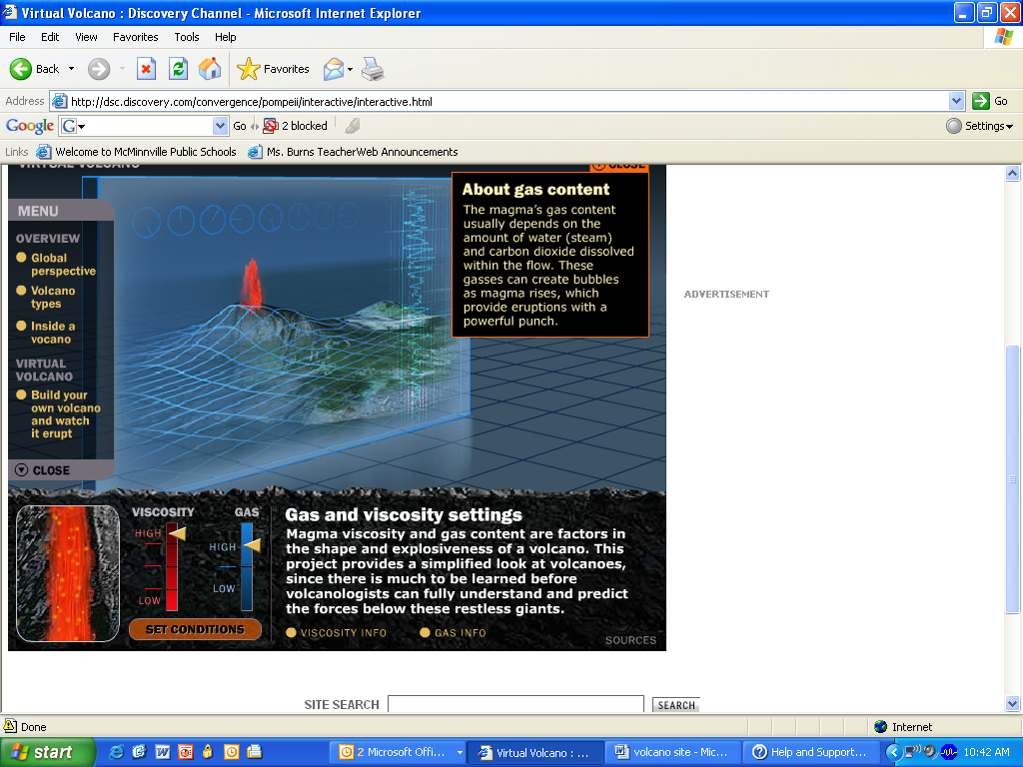
The magma in this window changes when you change the viscosity and gas.

  - When the viscosity is high the magma moves (circle one) slower or faster.
  - When the viscosity is low the magma moves (circle one) slower or faster.

- You can also change the gas content. Compare the low gas to the high gas setting. How is the magma different when it is on high? (Hint: Look at the bubbles)

Building Volcanoes (Hint: use the information above to help you make predictions)

- Shield Volcano – Gas setting: Low or high
  - Make a prediction: What viscosity setting will make a shield volcano?
  - Try it out. What type of volcano did you get?_______________________
  - If you didn’t get a shield volcano, keep trying. What viscosity setting makes a shield volcano? ___________________________
- Stratovolcano – Gas setting: High
  - Make a prediction: What viscosity setting will make a stratovolcano?
  - Try it out. What type of volcano did you get?_______________________
  - If you didn’t get a stratovolcano, keep trying. What viscosity setting makes a stratovolcano? ___________________________
- Dome (like a plug in the top of the volcanic vent) – Gas setting: low
  - Make a prediction: What viscosity setting will make a dome?___________________
  - Try it out. What type of volcano did you get?_______________________
  - If you didn’t get a dome, keep trying. What viscosity setting makes a dome?
___________________________
- Look back at your information. In general, how does viscosity affect the type of volcano and eruption? ______________________________________________________________

