Nelson Mandela

**Note:** this is an example of what it should look like, including format like bolding and underlining – not everything is filled in or complete.

Period 5

October 18, 2013

Activity 8 Data Toss Experiment:

Question: How does using one eye open vs. two eyes open

affect a person’s ability to catch the ball that is tossed to them

from 8 feet away?

**DESIGNING THE INVESTIGATION**

Materials:

* Use bullets
* For each item
* You use

Procedure:

1. Be sure to number your steps.

2. When you include diagrams, put them next to the step that refers to them instead of putting them all at the end.

3. If you can, figure out how to make the steps indent if they are more than one line. Look at the difference between step 2 above and this step. If you can’t figure out how to indent, don’t worry about it.

**COLLECTING AND PRESENTING RESULTS**

(see attached data table and graphs)

**ANALYZING AND INTERPRETING RESULTS**

Data Analysis

From the data, it appears that everyone, out of the 4 people tested, caught more of the catches with both eyes open. Each person caught at least 3 more of the tosses with both eyes open, and one person, RG, had a difference of 6 catches. The average number of catches was 11.75 for 1 eye open, and the average number of catches with two eyes open was 16. That’s a difference of over 5 more catches with both eyes open.

It also appears that there is a big difference depending on who it catching the ball. JN and MM had much higher number of catches than RG and JH.

Conclusion

When looking at my data, I can definitely say that it supported my hypothesis that using two-eyes would be easier. I say this because all people caught more with two eyes. I think that happened because (here insert your reasoning! You may have to look something up to find out why)

I also think that there was such a big difference in RG’s data because that person wears glasses and maybe their vision is already kind of bad. Also, RG was the first person I tested and so I might not have perfected my throws and a lot may have not been off target.

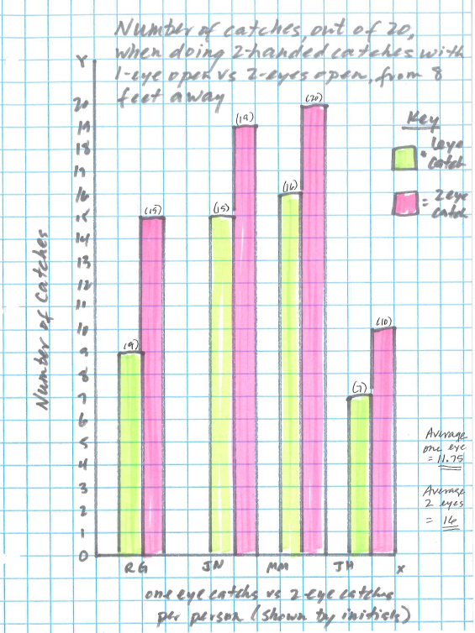

Error Analysis

(note these are just examples – they may or may not apply to yours, so think for yourself . . .)

Bad throws could have affected the data because it would have messed up the catch. We tried to make every throw as carefully as we could. The type of ball used also made a difference because . . . (you would explain why on your paper)

Another thing that could have changed the results might be the sun glaring in the window because . . .

Future Directions

I learned that there seems to be a difference between one eye vs two eyes, and I’m wondering if . . . (think about what else you’d like to test, maybe to compare to your test, or maybe an extension of your ideas)