IB Biology Name____________________________________
Circulation and Respiration Period________ Date ___________________

CIRCULATION

- What is the main purpose of the circulatory system?

- Show the path of blood flow from the right arm to the left leg by the most direct possible route. Use red arrows to show the path of oxygenated blood and purple arrows to show deoxygenated blood.

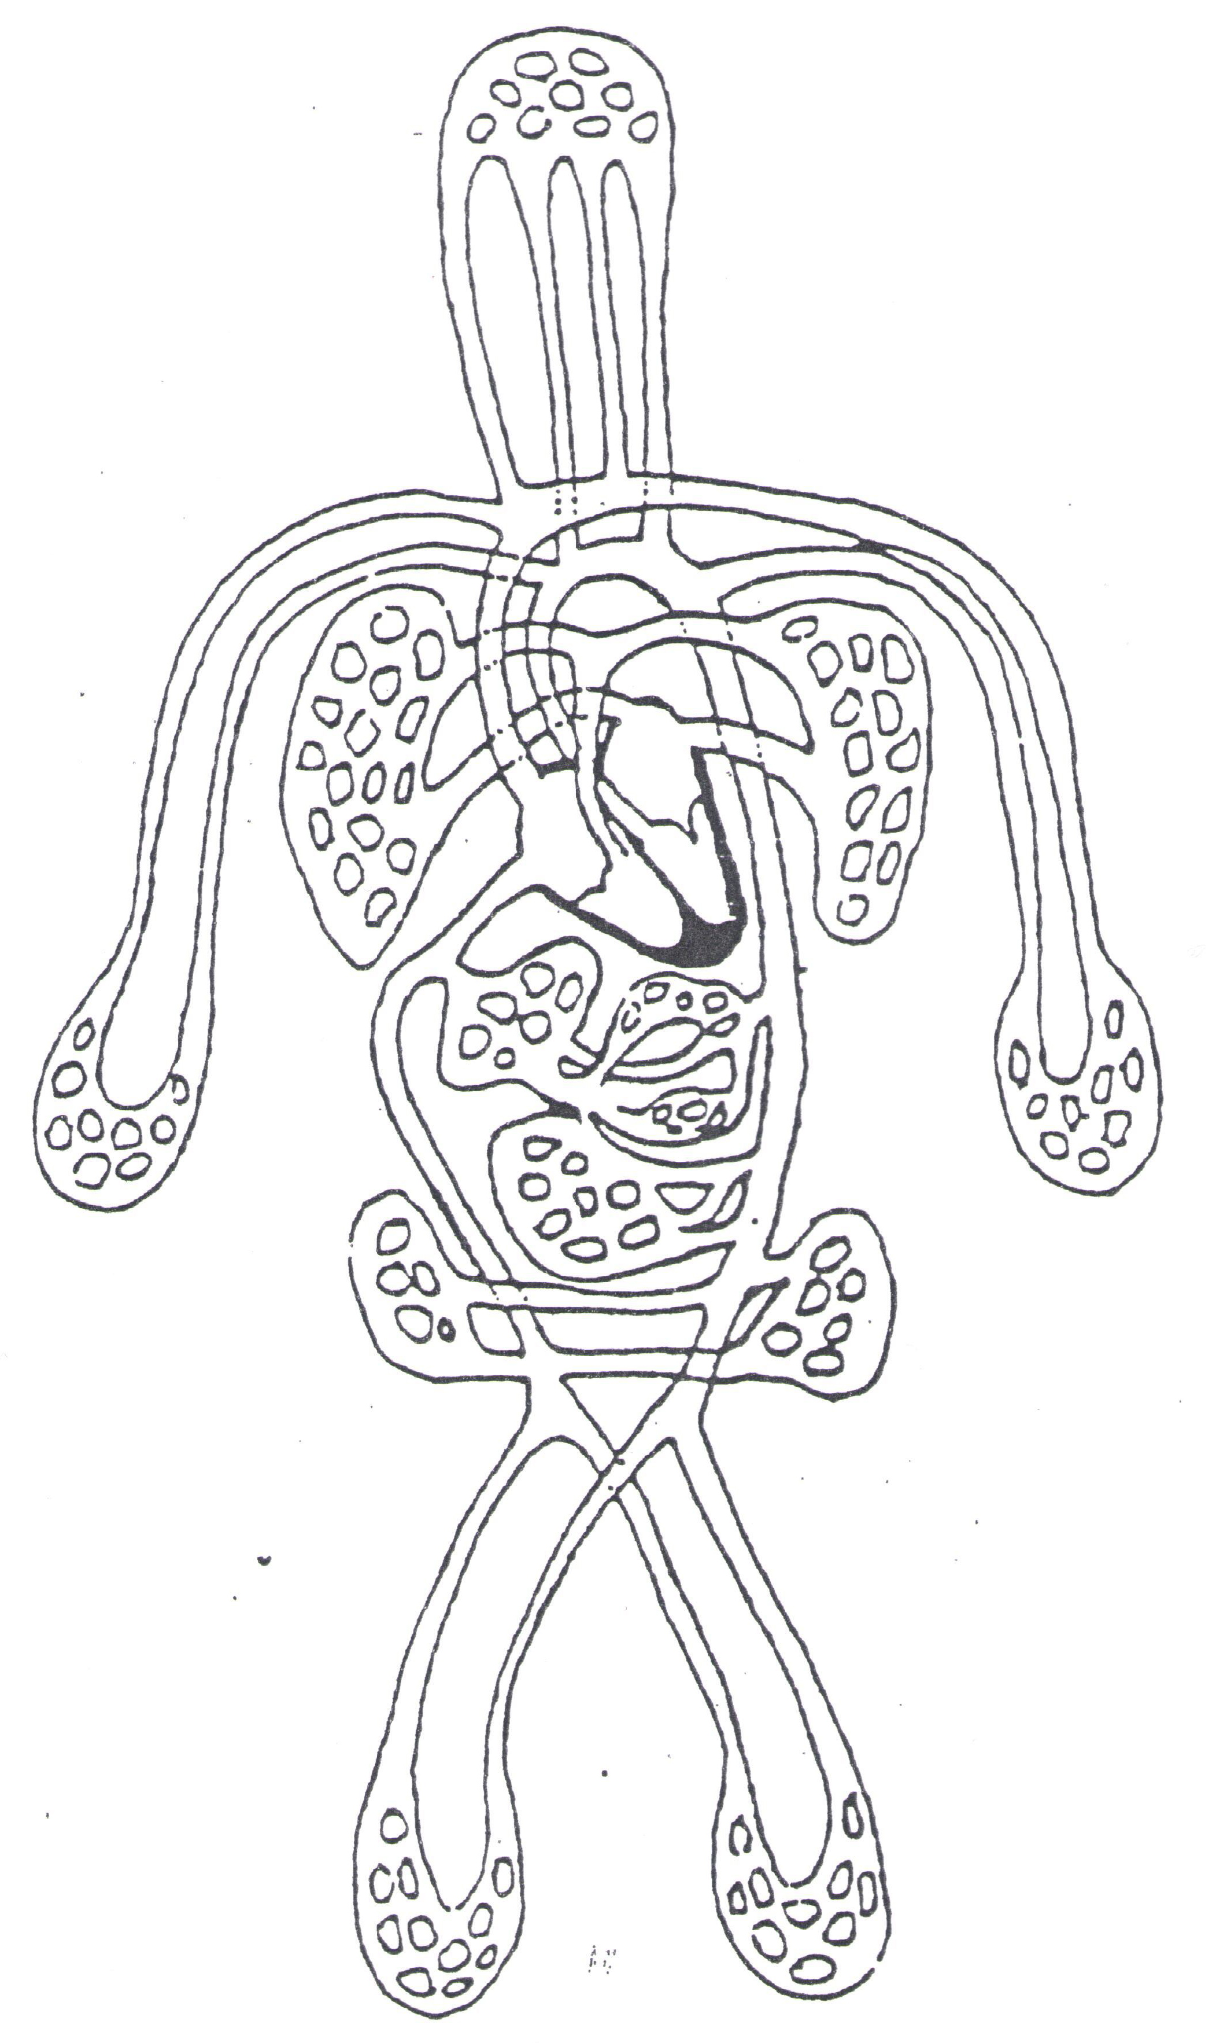

- In diagram A below label with the terms artery, arteriole, vein, venule, capillary. In diagram B label the terms artery and vein.

A. | B.
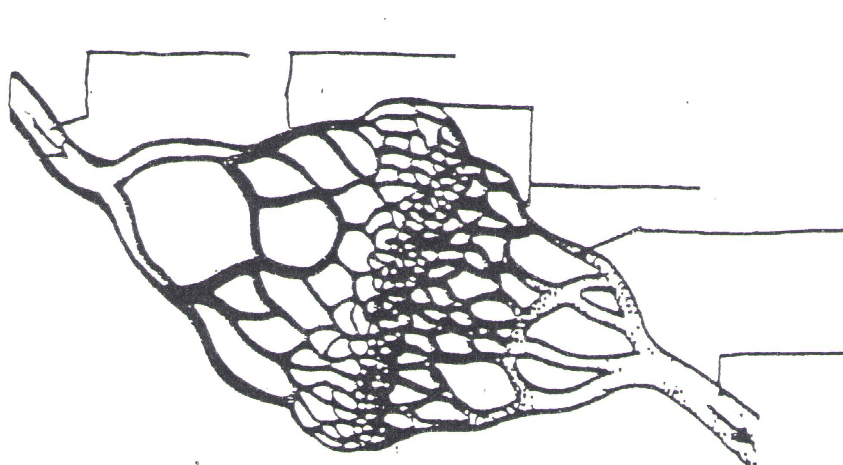 | 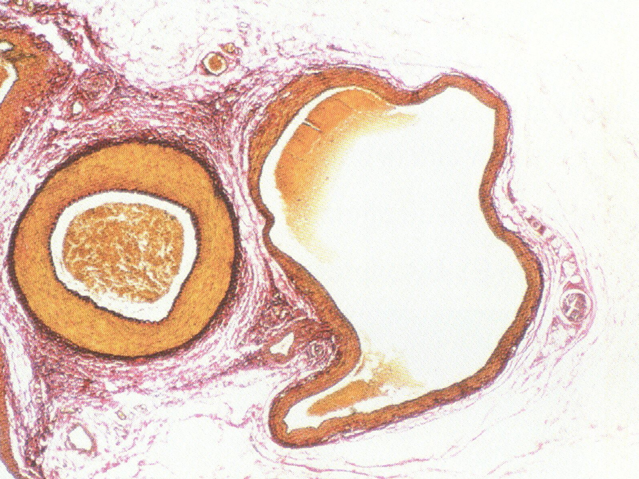

- Explain the relationship between the structure and function of arteries, capillaries and veins. (Oxford, p.294)

- Describe three research-supported discoveries by William Harvey about circulation of blood in humans. (Oxford, p. 290)

- Why must living cells be within 2-3 cells of the capillary bed?

- What are the causes and consequences of hypertension and thrombosis? (Oxford, p. 690)

- Interpret the blood pressure measurement of 145/99. Include a BP category assignment. (Oxford, p.691-692)

- How does the body stop blood when the blood vessels are cut? Describe this process. (Oxford, p. 303-304)

RESPIRATION

- Put the letter(s) of the function next to the structure that performs it:

__1. Nasal passages A. cleans air
__2. Larynx B. exchanges oxygen & Carbon dioxide between air & blood
__3. Epiglottis C. makes sound
__4. Trachea D. prevents food from going down the trachea
__5. Bronchus E. allows air to pass
__6. Bronchioles G. Causes inhaling and exhaling
__7. Alveoli
__8. Diaphram

- The alveolus is the basic unit of structure and function of the lungs. What happens there? Describe one way in which its structure fits this function.

- What are the causes and consequences of lung cancer? (Oxford, p. 316)

- What are the causes and consequences of emphysema? (Oxford, p. 317)

- Color: Airways - green
Oxygenated blood - red
Deoxygenated blood - purple
Diaphragm - blue
Show the path of air into one alveolus and back out. Use arrows.
Label the organs indicated by the arrows. Label diaphram as either relaxed or contracted.

