IB Biology Name _______________________________
Endosymbiotic Theory Period ____ Date ________________

Large Molecule Transport

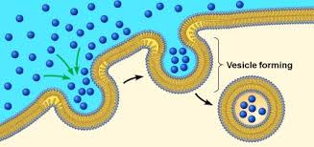 | Endocytosis
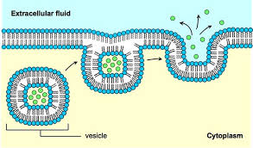 | Exocytosis

Summary of Endosymbiotic Theory:

Evidence:
1. Size:

2. Reproduction:

3. DNA:

4. Ribosomes:

5. Protein Synthesis:

