IB Biology
Data Analysis: Global Climate Change

All the data you will be examining comes from the publication “National Climate Assessment.” This report summarizes the science of climate change and the impacts of climate change on the United States, now and in the future. It is largely based on results of the U.S. Global Change Research Program (USGCRP), and integrates those results with related research from around the world. This report discusses climate-related impacts for various societal and environmental sectors and regions across the nation. It is an authoritative scientific report written in plain language, with the goal of better informing public and private decision making at all levels.

Find the link to the report on my website. Click on the highlighted “National Climate Assessment” in the first paragraph. Click on “Explore the Report.” Download the Full Report by clicking on the downward caret (∨) in the upper right hand corner. Click on “3.24 MB” next to Our Changing Climate. Use this chapter to answer the following questions:

- Look at the graph titled “Global Temperature and Carbon Dioxide.” (pg. 23) Does the relationship between CO₂ and temperature appear to be correlated? How closely? Do you think that one causes the other? How does a scientist distinguish between correlation and causation? (PDF pg. 17)

- Look at the graph titled “Separating Human and Natural Influences on Climate.” (pg. 23) What are the non-human, “natural” factors that are affecting climate? (PDF pg. 20)

- Look at the graph titled “Emissions Levels Determine Temperature Rises.” (pg. 26) Compare and contrast the two graphs. What accounts for the difference in the graph at the right? (PDF… skip)

- Look at the graph titled “Projected Precipitation Change by Season.” (pg. 34) How is Portland summer precipitation predicted to change? Winter precipitation? Be specific. (PDF pg. 31)

- Look at the graph titled “Past and Projected Changes in Global Sea Level Rise.” (pg. 45) How was data collected for these analyses? What accounts for the large projected range of sea level rise?

- At the end of the chapter read about confidence levels. Choose one key idea previously examined and discuss its confidence level. (PDF…skip)

Return to the Downloads Page. In Appendices click on “4.13MB” next to Climate Science Supplement.

- Look at the graph titled “Heat Trapping Gas Levels.” (pg. 739) What is the current (as of 2000) concentration of each gas? What might have caused all three greenhouse gases to sharply increase in the 17th-20th centuries? What changed in human history? (PDF pg. 14)

- Look at the graph titled “Atmospheric Carbon Dioxide Levels.” (pg. 740) What does this graph suggest about the current CO₂ levels in our atmosphere? How was this data collected? (PDF pg. 13)

- Have humans ever lived on Earth before with this much CO₂?

- Look at the graphs titled “Relative Strengths of Warming and Cooling Influences.” (pg. 741) What is the only non-human, “natural” factor affecting climate? (pg. 16)

- Is this “natural” factor having a bigger or smaller effect on climate? What is the effect?

- Are there human impacts that actually have a cooling effect? If so, what are they and how do they compare to the heating effects?

- Why might the size of the error bars representing uncertainty differ for different influences? Hint: think about what we use error bars to represent in our graphs.

- Look at the graphs titled “Emissions, Concentrations, and Temperature Projections.” (pg. 755) Determine the best and worse case scenarios in terms of atmospheric CO₂ concentration and global average temperature if no explicit climate policies are enacted (report actual values, not trends/SRES). (PDF pg. 23 and pg. 25)

 | CO2 concentration ( ) | Global Average Temp ( )
Best Case
Worst Case

- According to the graph below, does the amount of energy from the sun account for global surface temperature changes? Explain. The left y-axis label reads Solar Irradiance (W/m²). (Graph can also be found on page 23 of the Highlights section of report.)
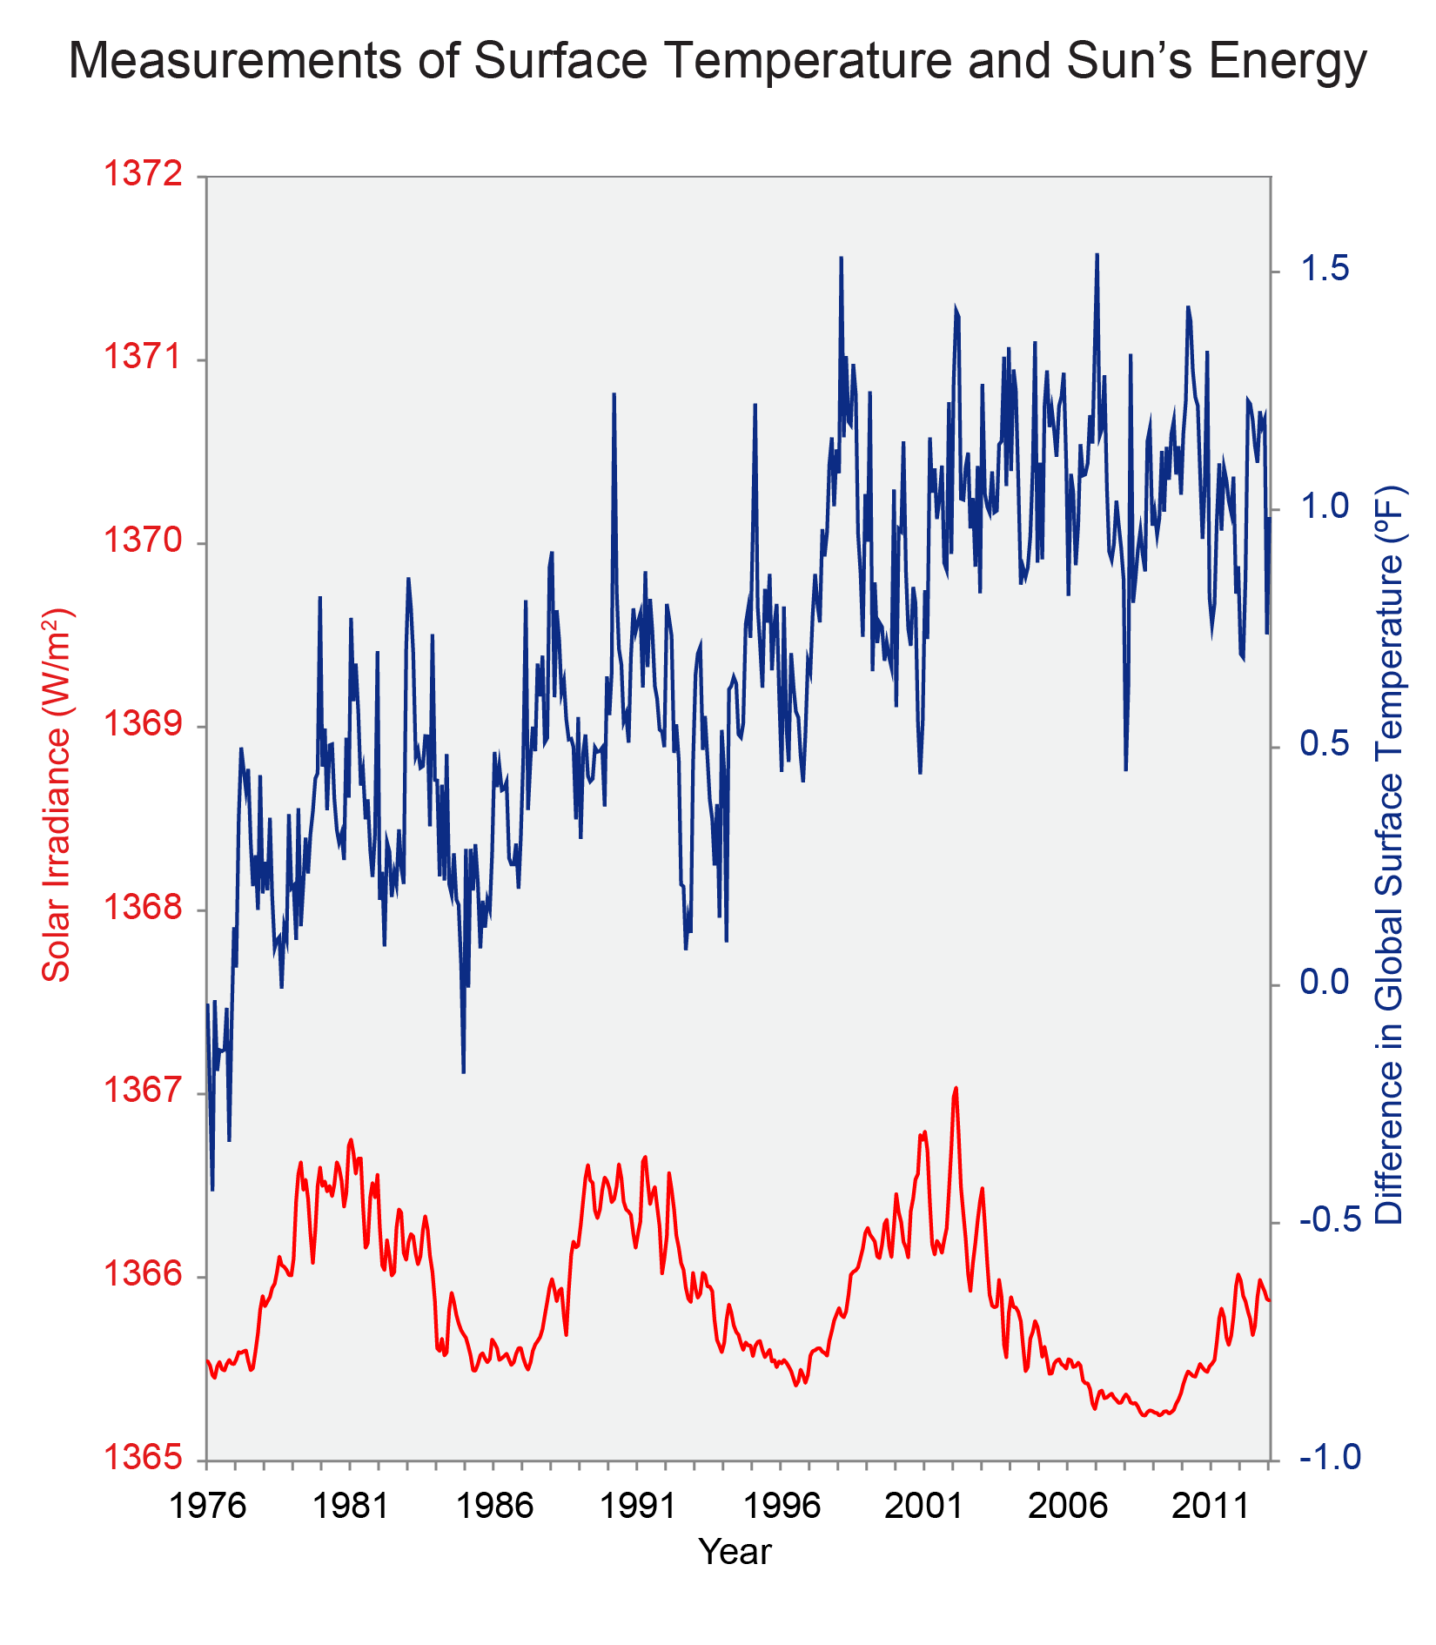

Unanswered Questions
- Now that you have examined a great deal of data on the subject of global climate change, what question(s) do you have?

- Because scientific claims are based largely on inductive observation, absolute certainty is difficult to establish. The precautionary principle argues that action to protect the public must precede certainty of risk when the potential consequences for humanity are catastrophic. In other words, if someone wants to do something that could cause grave danger to the public, even if that risk of danger isn’t 100% certain, they shouldn’t move forward until protections are in place. Evaluate (command term!) the precautionary principle as a justification for strong action in response to the threats posed by global climate change.

- Research online one location outside the U.S. that is already experiencing significant impacts from global climate change. Describe the location and the impacts.

