IB Biology Name _______________________________
Cellular Respiration in Germinating Seeds Period _____ Date ________________

Background:
Cell respiration refers to the process of converting the chemical energy of organic molecules into a form immediately usable by organisms. Glucose may be oxidized completely if sufficient oxygen is available by the following equation:

C₆H₁₂O₆ + 6O₂(g)6H₂O + 6CO₂(g) + energy

All organisms, including plants and animals, oxidize glucose for energy. Often, this energy is used to convert ADP and phosphate into ATP. It is known that beans undergo cellular respiration during germination.

In this activity, you will use a CO₂ Gas Sensor to determine the respiration rate of beans.

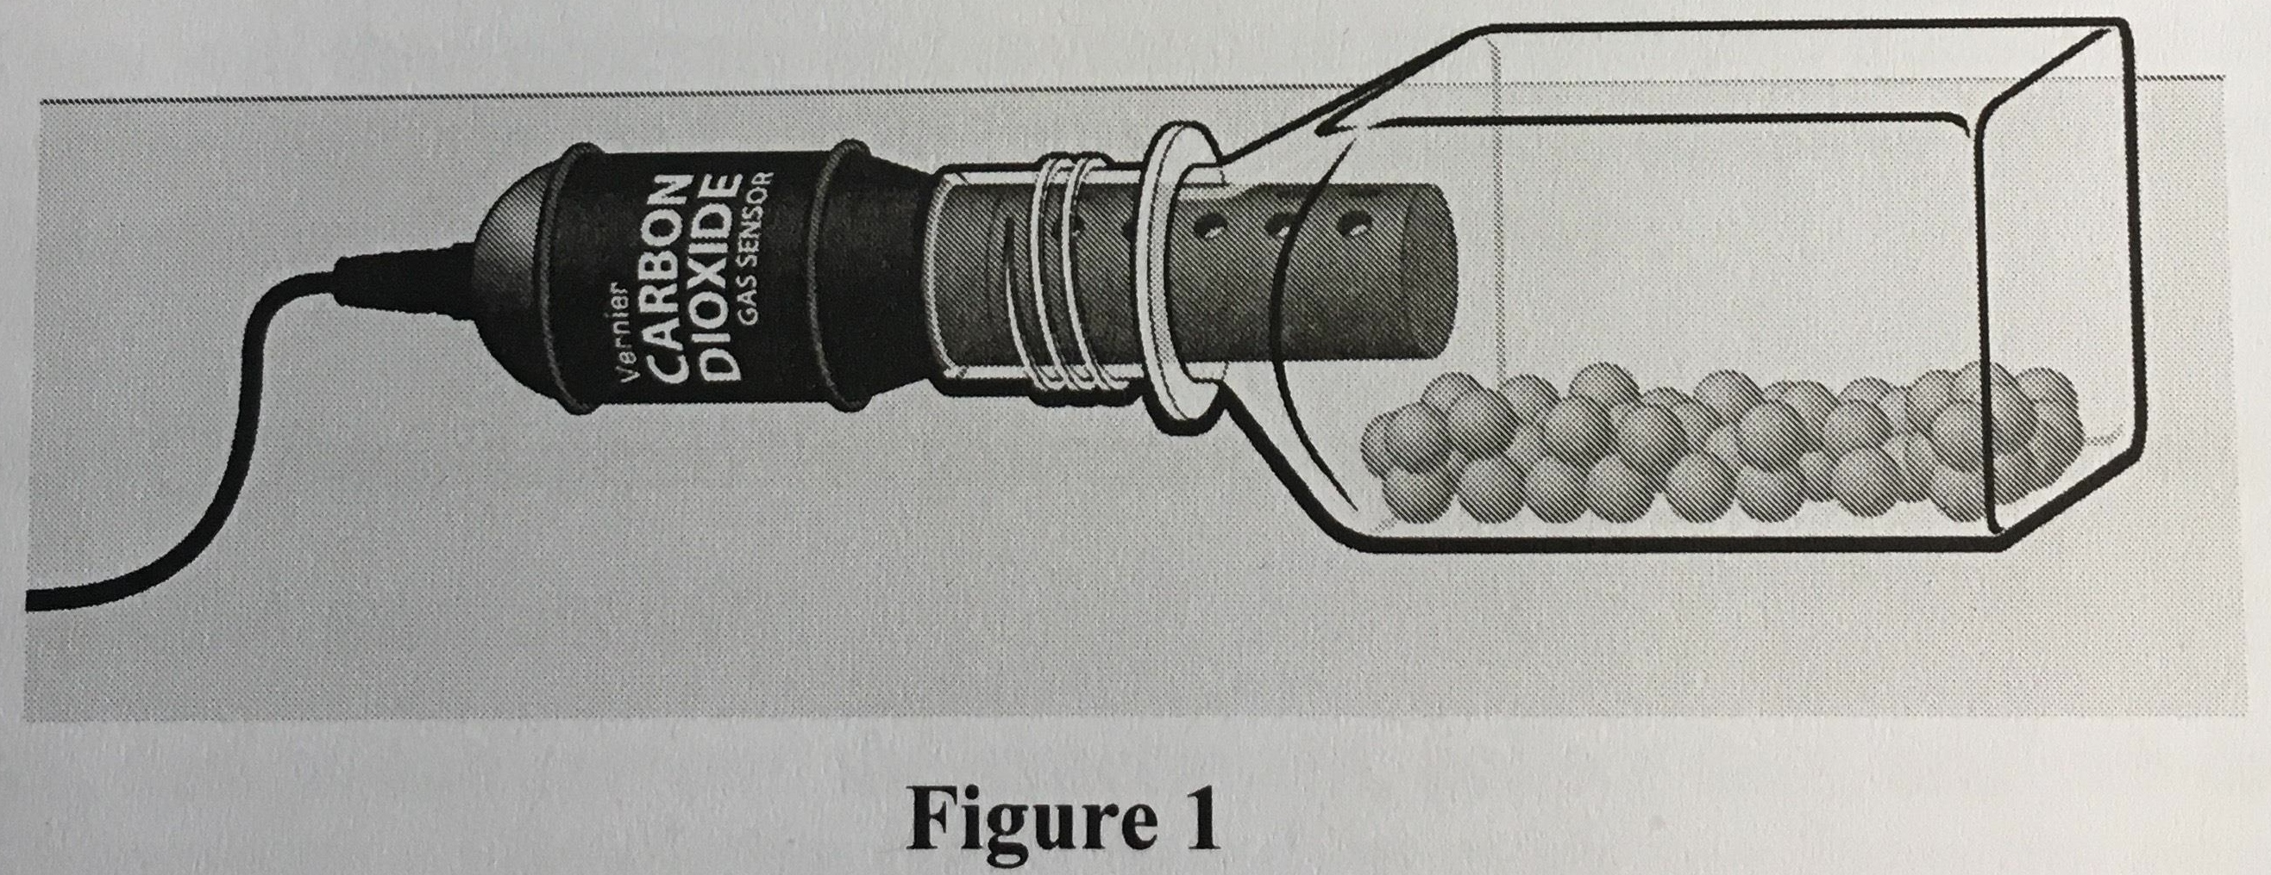

Procedure:
- If your CO₂ Gas Sensor has a switch, set it to the Low (1-10,000 ppm) setting. Connect the CO₂ Gas Sensor to the LabQuest.
- Turn on the LabQuest. Choose New from File menu. Hang the sensor over the edge of your table for 90 seconds to allow the sensor to warm up. It should read between 400-800 ppm. If it doesn’t, tell the teacher.
- Prepare the beans for data collection
  - Obtain 25 dry beans.
  - Determine and record the mass of the beans.
  - Place the beans in the respiration chamber.
  - Place the shaft of the CO₂ Gas Sensor in the opening of the respiration chamber and lay flat, as shown in Figure 1. (CO₂ is heavy, so don’t set the sensor upright in the chamber.)
- Wait 60 seconds, and then start data collection. Data will be collected for 600 seconds.
- After data collection is complete find the linear regression to determine the respiration rate. Click Analysis menu at the top of the graph, then Curve Fit. Check the CO₂ box. Choose fit = linear followed by OK. Record m (slope) as the respiration rate in CO₂ ppm/s. Also note the initial and final amounts of CO₂ at the beginning and end of your trial.
- Repeat the process with 25 germinating beans. Be sure to blot them dry with a paper towel before starting.
- When you are finished collecting all data, allow the sensor to return to ambient before turning off the LabQuest (90 seconds or more).

Analysis:
- Record the initial and final amounts of CO₂ measured for both dry and germinating seeds (ppm). Include uncertainty with your measurements.

- Use the respiration rate, in CO₂ ppm/s, and the mass of your beans, in grams, to calculate the normalized respiration rate per gram of both dry and germinating beans (CO₂ ppm/s/g). Show your work using the 4-step method. You do not need to propagate uncertainty today

- Do the results of this investigation verify that germinating beans undergo cellular respiration? How do you know?

- Why do germinating beans undergo cell respiration?

- List three factors that could possibly affect cell respiration rate in beans/seeds.

- List one focused question concerning cell respiration.

