IB Biology Name ________________________________
Antibiotics and Antibiotic-like Substances Period ________ Date _______________

Purpose: Antibiotics such as ampicillin or streptomycin are major chemicals used in combating disease. These drugs stop the spread of infections by killing bacteria. They block metabolic processes that occur in prokaryotic cells, but not eukaryotic cells. Viruses lack a metabolism and therefore cannot be treated with antibiotics. Some strains of bacteria have evolved with genes that confer resistance to antibiotics and some strains of bacteria have multiple resistance.

In this investigation adding the antibiotic to a bacterial culture tests the effectiveness of an antibiotic. You will test two different antibiotics and fresh garlic, claimed to have antibiotic properties. Clear zones on the culture around the antibiotic disk indicate lack of bacterial growth. These areas are called zones of inhibition.
clear zones or zones of inhibition

disks

Materials: Petri dish with nutrient agar, sterile cotton swab, forceps, antibiotic disks, sterile paper disk, broth culture of E. coli, metric ruler, fresh garlic

Procedure:
- With a permanent marking pen, divide the bottom of your petri dish into four quarter by marking the outside of the dish bottom. Identify each quadrant with a marking that will designate what you will place there. Write your initials and class period on the side of the petri dish.
- Using sterile technique remove the plug from the E. coli broth culture.
- Dip the cotton swab into the broth culture.
- While still holding the swab and plug in one hand, replace the plug in the test tube.
- Raise your Petri dish cover slightly. Starting at the top, swipe the cotton swab across the entire agar surface. Use a back and forth motion to ensure that the entire surface has been covered with broth culture. Now turn the dish a quarter turn and re-swipe the swab across the agar surface. Use the following picture as a guide.
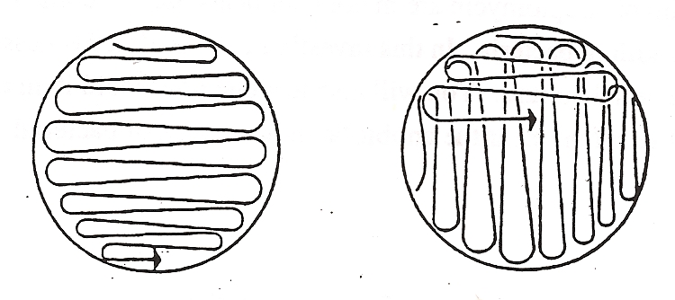
- Replace the cover of the petri dish. Dispose of the swab by first burning the end and then placing it in the beaker at the front of the room. The agar has now been inoculated with the bacteria in the broth culture. The bacteria will reproduce and form colonies on the agar.
- Obtain two antibiotic disks (streptomycin and ampicillin). Use sterile forceps to place each disk in the center of a separate quarter of agar. Press each disk lightly onto the agar.
- Prepare your test disk by soaking it in the garlic juice created by crushing the garlic clove. Place this disk in the third quarter of the petri dish. Press each disk lightly onto the agar.
- Add a plain sterile disk to the last quarter of the petri dish. This disk will act as a control.
- Replace the cover on the petri dish. Obtain a piece of parafilm and secure it around the edge of the dish, stretching it gently and pressing it down. (Your teacher will demo this.) Turn in your petri dish to be incubated. Incubation will take 24 to 72 hours.
- Create a data chart of your own design in which you will record the raw and transformed data after incubation of your own petri dish and that of all your classmates. Be sure to include a place for both quantitative and qualitative data, including t-test results. Bring this to the next class period.

Assignment: Read carefully and save yourself some work! Turn in the following:

- This handout with your teacher’s initials, indicating your prepared your data chart for data collection.
- Data charts with descriptive titles, labels, units, uncertainty and annotation(s). You will need one for raw data and an additional chart for the results of your t-tests (calculated value of t, degrees of freedom, p value, and whether or not there is a significant difference between the conditions). NO SAMPLE CALCULATIONS REQUIRED. You’re welcome!
- A conclusion in which you compare the antibiotic properties of fresh garlic to ONE of the antibiotics. Discuss your averages and the results of your t-test and what they mean. Also include ONE limitation.
- An evaluation in which you describe ONE weakness or error, its impact on your data, and a specific suggestion for improvement.

