IB Biology Name ___________________________
Cell Review Date ______ Period _______________

1. Label the parts of the composite cell below.

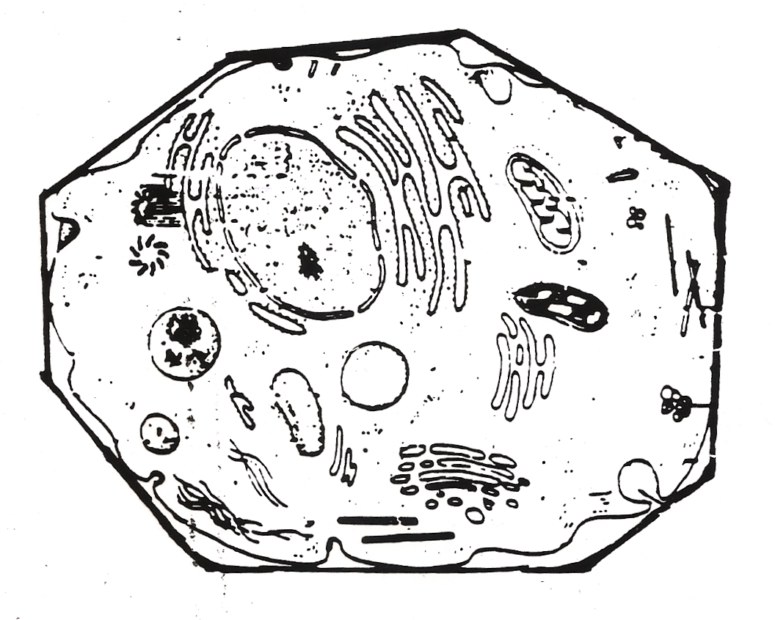

2. What is a composite cell?

3. What parts of a cell are found only in plant cells? Only in animal cells?

4. Why are compartments (membrane bound organelles) valuable to eukaryotic cells?

over→
5. Label the electron micrograph of a liver cell below. Include the nucleus, mitochondrian, Golgi apparatus,
rough endoplasmic reticulum, lysosome, and free ribosomes.

