Essential Questions About Cells

- Outline the cell theory. Describe evidence that supports the theory, including the experiments of Louis Pasteur.

- Describe three advantages of both a light and an electron microscope. Provide examples of an organism or part of an organism that would best be viewed using each type of microscope and describe why they would be best viewed using that microscope.

- Compare and contrast prokaryotes and eukaryotes. Provide several examples.

- Draw and label the structure of plasma membranes. Describe the function of each part of the membrane.

- Draw and label a diagram of the ultrastructure of the bacterium E. coli. Describe the functions of each ultrastructure.

- Explain a possible endosymbiotic relationship that may have evolved between prokaryotes. Include evidence for the theory and the possible origin of mitochondria and chloroplasts.

- Describe the relationship between volume and surface area in cells. Describe exceptions to the idea that cells cannot get too big.

- Describe levels of complexity among organisms. Include examples at each level. Why are multicellular organisms composed of eukaryotic cells instead of prokaryotic cells?

- Distinguish between active and passive transport (all three types). Provide examples to support your explanation.

- Distinguish between endocytosis and exocytosis. Describe examples of types of cells or organisms that use these processes.

- Describe the different phases of the cell cycle. What is the product of mitosis? What is cancer? How is it related to a discussion of the cell cycle?

Assignment: Write essay outlines for each of these questions. Star the questions that are found in the Syllabus Details. Use these outlines to prepare for the essay test at which you will draw 3 questions from a hat and answer two of them. You will NOT be able to use your outlines on the test.

Cell Review

- Label the pats of a cell below.

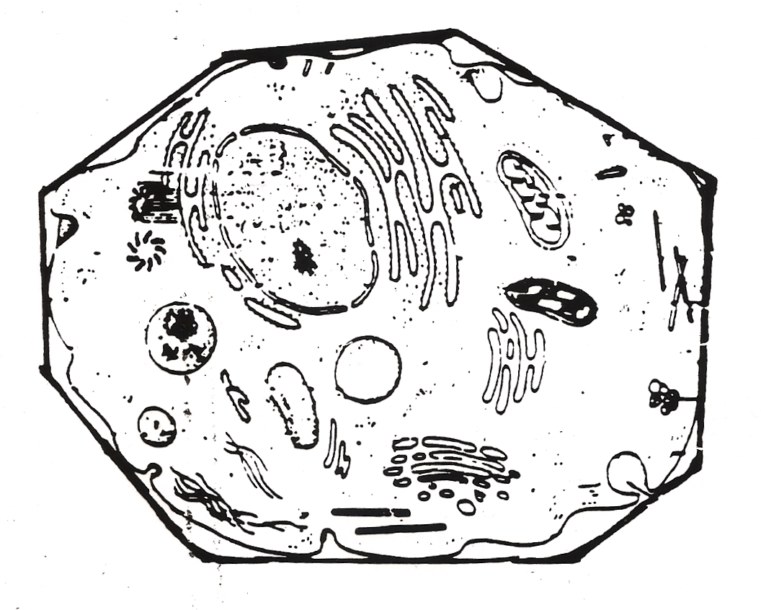

- What is a composite cell?

- What parts of a cell are found only in plant cells? Only in animal cells?

- Why are compartments valuable to a eukaryotic cell?

