IB Biology Name __________________________
Circulation Drama Period _____ Date _______________

- Which parts of blood were represented in the drama?

- Fill in the data chart completely.

Molecule | Carried by… | Picked up from… | Dropped off at…
food

oxygen

carbon dioxide

uric acid

- Below is a sketch of what was drawn on the floor of the room. Use arrows to show the direction of blood flow through the heart.
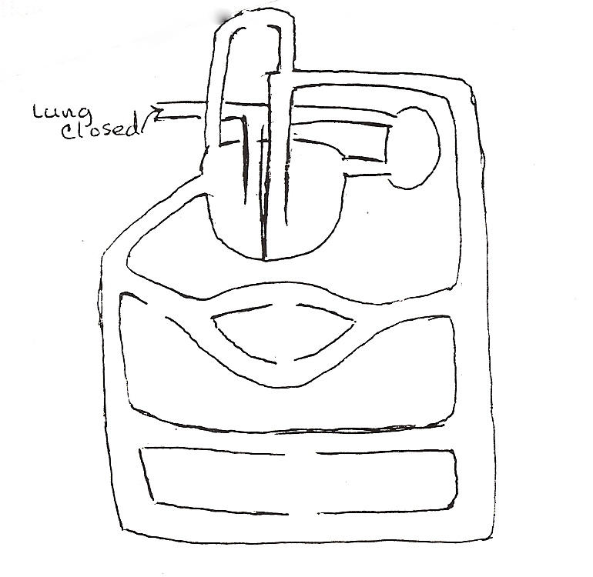

- Why did we use the stool and table?

- What is the basic difference between a vein and an artery? Use what you learned during the drama to answer this question.

- How could we demonstrate a heart attack? A stroke?

