IB Biology 3-4 HL Name ________________________
Cladograms Activity Period _____ Date _____________

Pick a group of organisms that you want to compare and a protein to work with. Your organism group should not be the same as your neighbors.

Proteins that frequently work:
Animals (pick one):
- Cytochrome B
- Cytochrome C Oxidase Subunit 1
- Cytochrome C Oxidase Subunit 2
- Myoglobin
- Others may work…search the database to see what has been submitted for the species you are interested in studying!
Plants:
- Ribulose bisphosphate carboxylase large chain

Procedure:
- Go to Uniprot and click on “Protein Knowledgebase” under “Core Data” at the bottom of the site.
- Now it is time to select the protein sequences you will compare. Type in the name of a protein and species name (you can use common or scientific names) in the Query window. Example 1: cytochrome B bird (will find all birds). Example 2: cytochrome B penguin (will find all penguins). Hit search. You can also use genus names for more specific searches.
- YOU MUST USE THE SAME PROTEIN FOR ALL THE SPECIES YOU COMPARE. For example, cytochrome b is NOT the same thing as cytochrome b5. Check under the “Protein names” and “Gene names” columns to make sure that everything matches. Ideally, pick sequences of the same length; this will give you a stronger analysis (length is listed as the final column in the results).
- Click accession number boxes for any species you want to compare (at least 5). Type the numbers and names of the species into your document so that you can identify them later. You can do this in a single search or in multiple searches. If you do multiple searches, you need to put the selections into your basket and then align them from the basket. (I can show you if you have questions).
- BEFORE you run the alignment, please predict a cladogram for the species showing which ones you think are most related. Sketch the cladogram.
- Hit “Align” button at the top when all species are selected. WAIT! This can take awhile (20 seconds to minutes).
- Under amino acid properties, click the “similarity” box. Describe the differences you see between the species. Which has the most variations in amino acids? The fewest?
- Check several of the other boxes and notice what you see. Pick 2 of the amino acid properties and describe them.
- You will notice a “guide tree” at the bottom of the page, but we want to do some further analysis, so we will have to copy down the alignment first. There is a blue “download” button above the alignment. Click on that button. In the box, leave “text” choose “uncompressed” and then “GO.” Copy the URL. Use a new window to open the next program, so that you can go back to your alignment if you need to!!

If you have updated versions of Java (works well on PCs, Macs may work), you can make a more advanced tree…Go to Jalview
- Click on “Launch Jalview Desktop” in the upper right hand corner.
- You will see a tab in the lower left. Click on that and let it open. You will see some demo windows pop up. Close them except the last one that appears blank. Click on “File” → “Input Alignment” → “from URL” and copy in your URL. Delete the “http://www” before you paste.
- Make a tree of your species (Calculate → Calculate Tree → Neighbor Joining → PID( % Identity). Other trees may give you an answer that makes more sense. Try making other trees, such as Average Distance trees.
For any tree you make, show your distances (View → Show Distances).
Make your font bigger (View → Font → Size 24 → OK).
Take a screen shot (“Print Scrn” button on PCs, option+shift+4 on Macs) of your most logical tree and paste it into your document (discuss with classmates and your instructor when you’re picking a tree).

Example Tree with Distances:
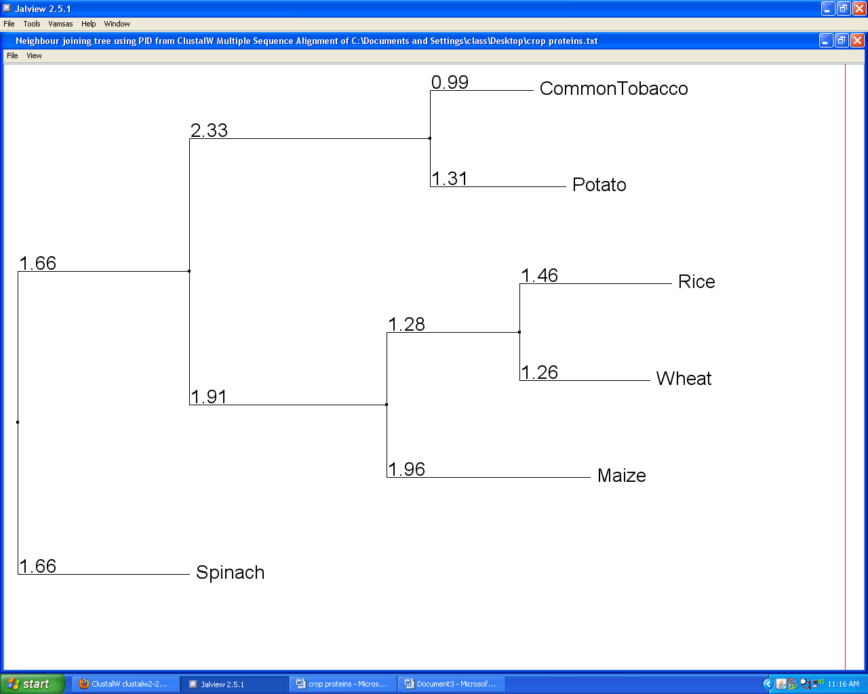

Concluding Questions:
- Is the cladogram close to what you predicted? Does it make sense to you? Why or why not?
- Use the numbers listed to calculate evolutionary distances between all of the species. (Add the numbers as you go from one species to another on the tree).
- According to the cladogram, which 2 species diverged the longest ago? How about the most recently?
- What information was used to make this cladogram? Be specific.
- Do you think that this information was adequate to determine the evolutionary lineage of these species? Why or why not?
- What further information could you seek out to strengthen the conclusions made here?

Teacher Notes:
- This activity takes 90 minutes!
- Must use recent laptops with updated Java! Mobile lab #3 or #4.
- In mobile lab #4, computer #1 didn’t work for this activity.
- To use the basket, when all organisms there, click on basket, check all boxes and align from that window.
- Note areas in sequence of protein where there are differences. (Only darkest highlighting is the same in all organisms.) You should be able to describe which organism is the MOST different from the others and which are more closely related (have fewer differences).
- If copying the URL for alignment shows a blank page, try refreshing. Leave as text. Check “uncompressed.” This is the part that might not work on some computers. Good luck! Switching computers helped.
- In the example, the cladogram shows numbers that represent the % difference in that protein from the common ancestor at the nearest node. Therefore, common tobacco has more in common with the common ancestor than the potato.
- To calculate the evolutionary distance, add all numbers as you travel from one organism to the next. Ex. Common Tobacco to Rice = 0.99+2.33+1.91+1.28+1.46
- Greater evolutionary distances implies more time since divergence as more time allows for more mutations to occur.
- Typically length of line = amount mutations since branching (longer=more mutations=bigger number).

