IB Biology Name _______________________________
Digestive System Period ____ Date ____________________

Directions:
- Color the alimentary canal green and the glands light blue.
- Use the arrows to show the path of the food through the system.
- Label all parts indicated by arrows.
- Label the microstructures shown on pages 3 and 4.

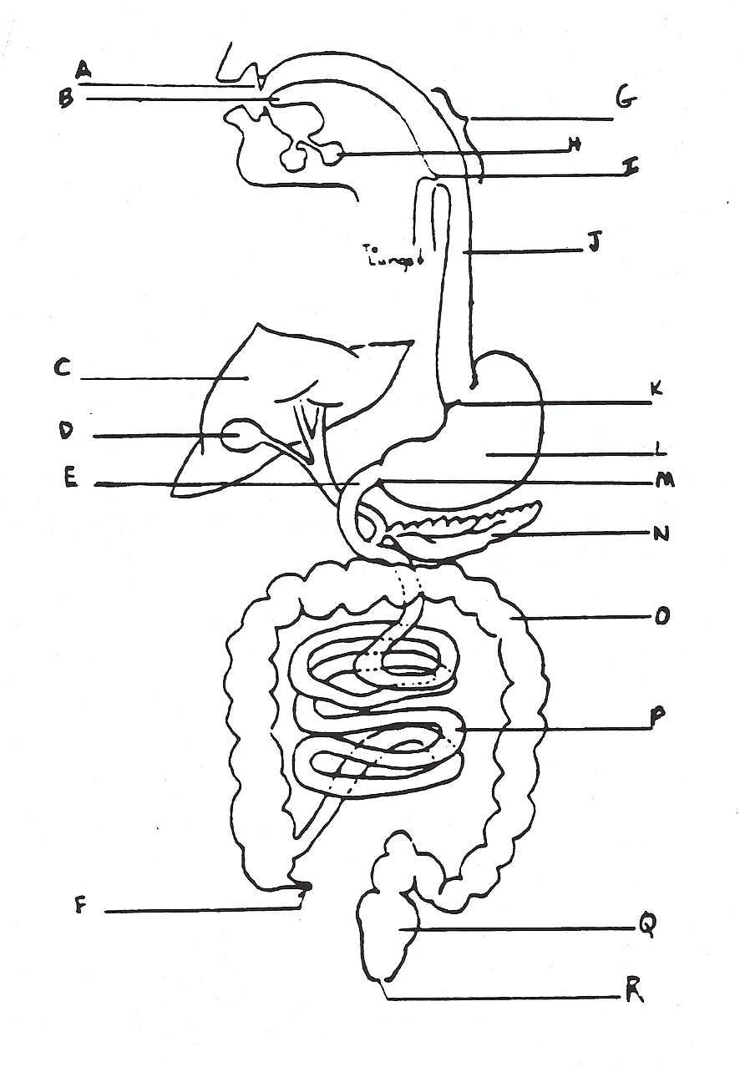

1
- State the source, substrate, products and optimum pH conditions for one amylase, one protease, and one lipase used in human digestion. (Remember, “-ase” is the ending we give to enzymes… refer to Joe Eats a Burger for help)

Enzyme  Category | Name of Enzyme | Source | Substrate | Products | Optimal pH
amylase
protease
lipase

- What is the difference between absorption and assimilation?

- Describe three ways the structure of the small intestine is related to its function.

- Outline the DIGESTIVE functions of the following:

Cardiac Sphincter

Liver

Pancreas

Gall Bladder

2
Problems with the Digestive System (pages 675-677 in Oxford Text)

- What bacteria causes ulcers? What 3 factors slowed the acceptance of this cause in the medical community?

- What are proton pump inhibitors used to treat? How do they work?

- What effect does the bacterium Vibrio cholera have on the digestive system?

Microstructure Labeling continued…

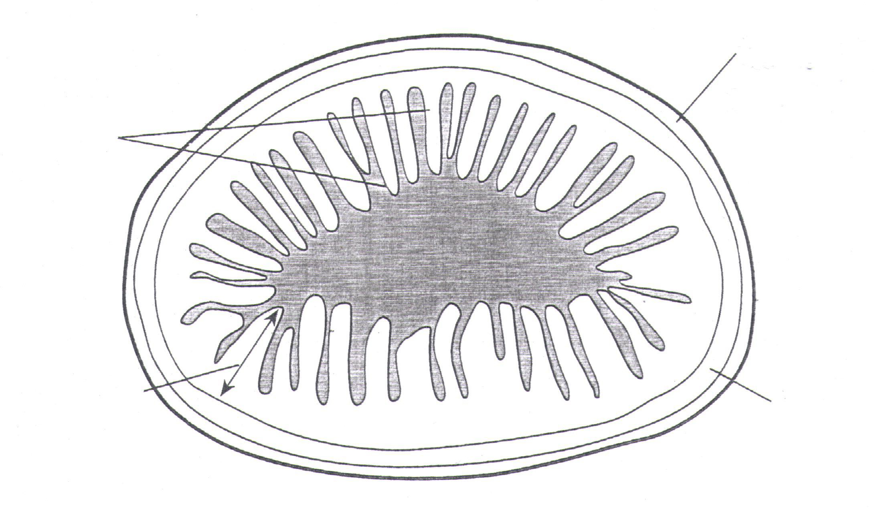

Transverse section of ileum (see page 673 in Oxford Text)

3
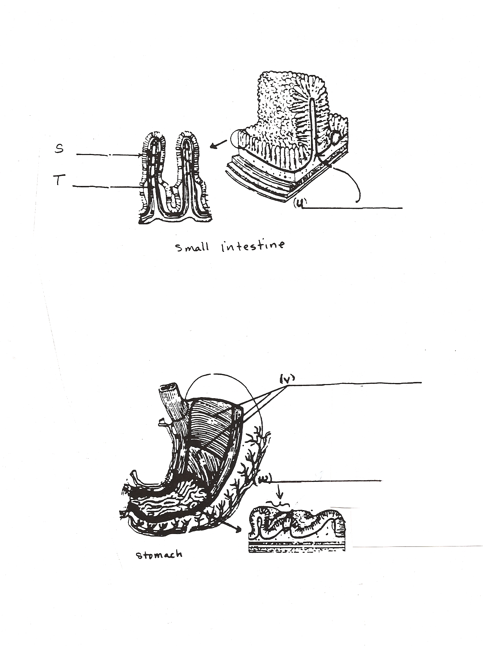4

