IB Biology Name ________________________________
Human Physiology Data Analysis Period _______ Date _______________

A link was postulated between the use of the triple measles, mumps, and rubella (MMR) vaccine and the rise of childhood autism. The MMR vaccine was introduced in Britain in 1988 after a measles outbreak killed 17 people. Though very considerable research has shown there to be no connection, some people continue to believe in such a link and they propose use of three single vaccines instead.

1. Suggest two reasons for doctors advocating one triple rather than three single vaccines. [2]

The MMR vaccination is optional in the UK. The data in Figure 9 shows the percentage of children vaccinated (MMR uptake) over a 13-year period in the UK.
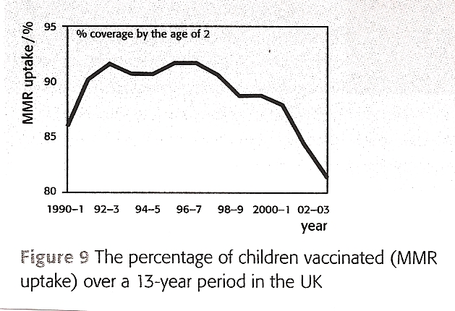

2. Outline the pattern of MMR uptake over the period shown in the graph. [2]

- Suggest, giving a reason, a year in which the UK media may have carried a story about research making a link between MMR and autism. [2]

In Japan, the MMR vaccine was introduced in 1989, but the program was terminated in 1993 and only single vaccines used thereafter. The data in Figure 10 shows the incidence of autism in Japan for children grouped by the year that they were born in.
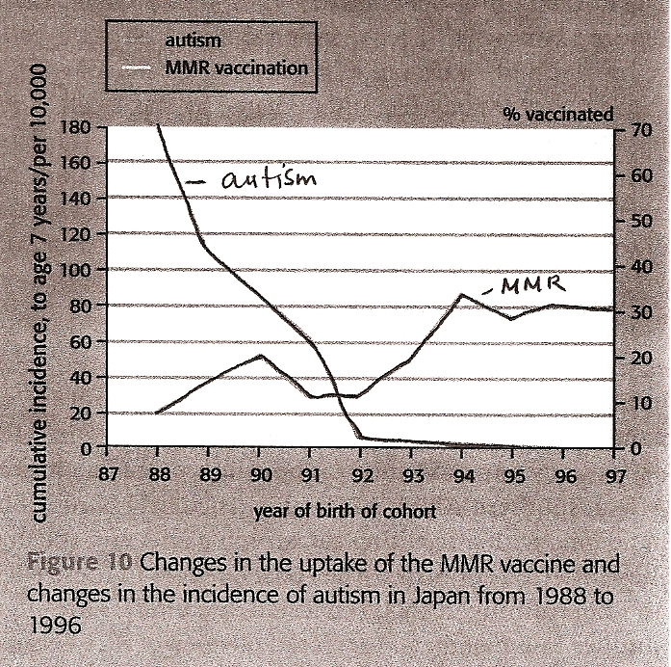

- Evaluate using the data the claim that autism is positively linked to the MMR vaccine. [3]

The CDC (Centers for Disease Control and Prevention) is responding to an outbreak of respiratory disease caused by a new coronavirus that was first detected in Wuhan City, Hubei Province, China and which has now been detected in 60 locations internationally, including the United States, as of March 2, 2020. Symptoms include fever, cough, and shortness of breath. (cdc.gov)
Figure 11 Figure 12
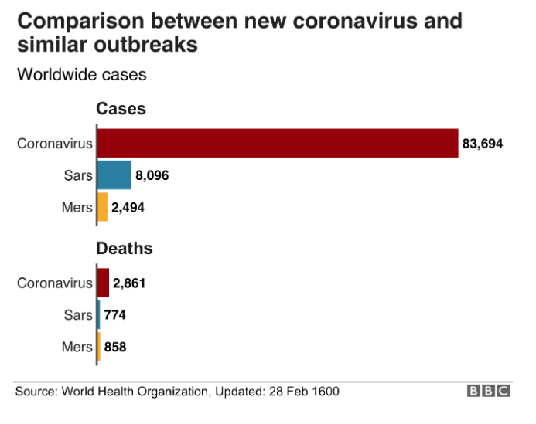 | 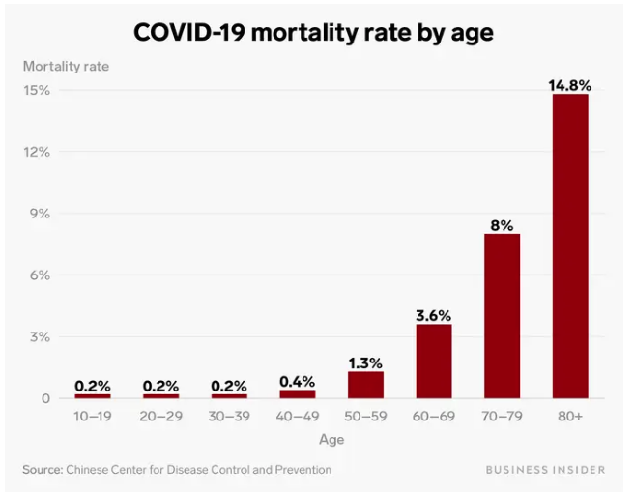

- Compare and contrast COVID-19 (Coronavirus) with similar outbreaks. [2]

- Outline the pattern of mortality in COVID-19 according to age. [1]

- State a limitation of the data presented in Figure 12. [1]

- Suggest one reason why the CDC does not recommend that people who are well wear a facemask to protect themselves from COVID-19. [1]

- Describe whether Florey and Chain’s tests on the safety of penicillin would be compliant with current protocols on testing. (Oxford pg. 307-8) [2]

Adapted from Biology Course Companion, Allott and Mindorf, Oxford University Press 2007

