IB Biology Name ______________________________
Nervous System Period _______ Date _____________

Use the textbook and your notes to answer the following questions.

- On the diagrams below color the central nervous system blue and the peripheral nervous system brown.
- Label the hypothalamus in the brain. Describe two functions of this area already discussed in class (Campbell pg. 1070)

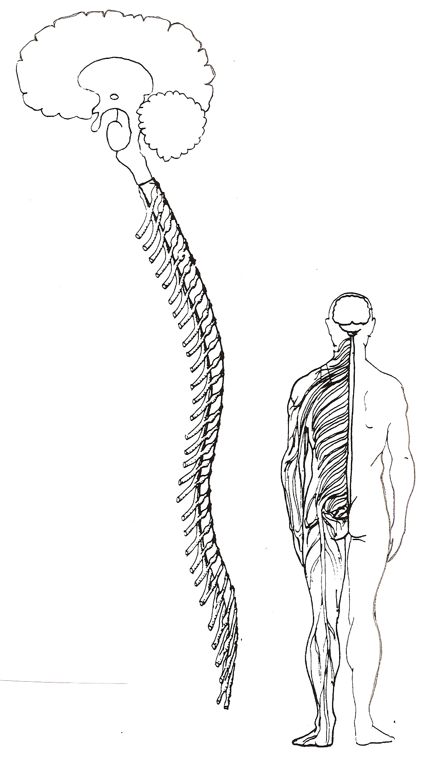
- On the diagram of the reflex arc below label the following structures: synapse, sense receptor, sensory neuron, motor neuron, relay neuron, effector.
- On the sensory neuron label the dendrites, nerve cell body, and axon.
- Color the peripheral nerves brown and the central nervous system blue.
- Indicate the direction of nerve impulse transmission using arrows. Remember, it is a reflex arc.
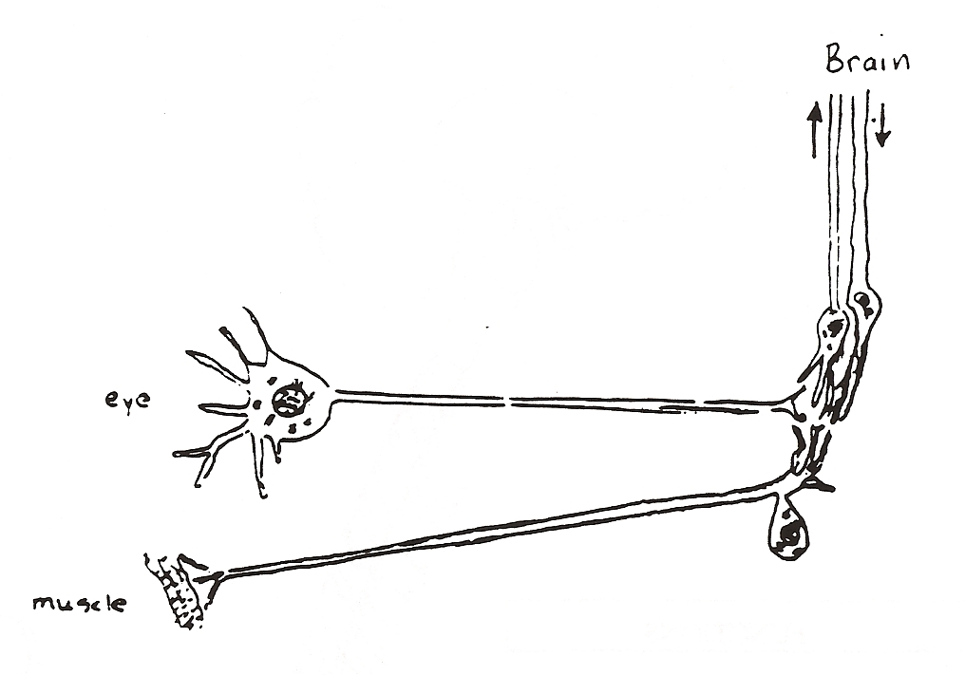

- Explain an example of diffusion, active transport, facilitated diffusion, and exocytosis in neural signal transmission within or between neurons.

- What is a neurotransmitter? (Campbell pg. 1058)

- What is the difference between inhibitory and excitatory neurotransmitters? Be sure to include the effects of these on neuron permeability. Give an example of each type of neurotransmitter.

Type of  Neurotransmitter | Definition | Effect on neuron permeability | Named example
Excitatory

Inhibitory

- What is acetylcholinesterase? (Campbell pg. 1060) Why is it important? Are there any other molecules that have a similar kind of function?

- How does integration take place at synapses? Include both spatial and temporal integration. (Campbell pg. 1058-9)

- How do neonicotinoids work? Discuss one advantage to using neonicotinoids in pesticides. (Oxford pg. 326)

