IB Biology Name ________________________________
Plasmolysis Lab Date ____________ Period _______

Part 1: Onion Epidermis
Purpose: To observe turgid and plasmolysed cells in onion cells

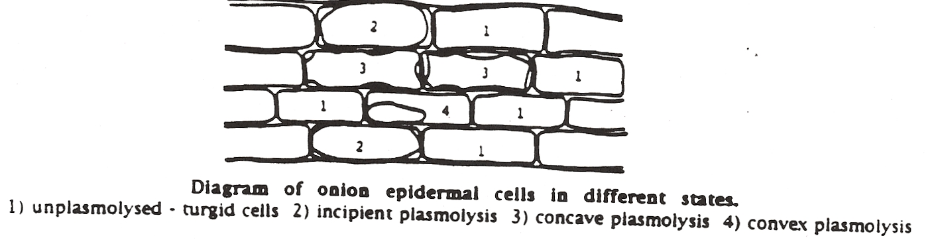

Observe epidermis cells mounted in tapwater. Recognize turgid cells. Add saltwater. Observe plasmolysis.

Describe plasmolysis, including the reason why this is a phenomenon observed in plant cells rather than animal cells. Include why the process occurred only when the cell was in a hyperosmotic environment.

Part 2: Blood cells
Purpose: To describe the effects of isosmotic, hypoosmotic and hyperosmotic environments on red blood cells
Examine the three SEM photomicrographs of red blood cells.

Which photograph shows cells in a hypoosmotic environment? _____ How do you know? Describe what caused this.

Which photograph shows cells in an isosmotic environment? _____ How do you know? Describe what caused this.

Which photograph shows cells in a hyperosmotic environment? _____ How do you know? Describe what caused this.

Part 3: Saline Solutions
Predict, with a reason, whether saline solutions used to rinse wounds and pack organs for transplant would be hypertonic, hypotonic, or isotonic.

