IB Biology Name ______________________________
Recombinant DNA Simulation Period _____ Date ___________________

Introduction: Today you will simulate the way in which the techniques of DNA technology are used to clone the human gene for insulin into a plasmid molecule.

DNA Assembly
- One pair in each group of four will work with the human DNA sample. The other pair will work with the plasmid DNA sample. Color the appropriate template diagram for your two-person team to reflect the molecules as described in the key. This will facilitate assembly of the structures.

- Each pair in a group assembles either the human DNA or plasmid DNA according to the key. Keep in mind that DNA 5’ ends have terminal phosphate molecules (smooth end) and DNA 3’ ends have terminal deoxyribose molecules (knob end). The top and bottom strands of DNA are antiparallel (the top strand is oriented left to right and the bottom strand is oriented right to left).

- Once the DNA structures are assembled, check the structure created by the other pair in your group against the template. Even small mistakes can have a large impact in recombinant DNA technology. Accuracy is crucial to success.

- The human DNA sample is a linear piece of DNA and should look just like the template when assembled. However, the plasmid DNA is a circular molecule and must be assembled into a ring. To do this
  - fasten a twist tie to the top strand between the phosphate and sugar of the first nucleotide in order to keep track of the top and bottom strands.
  - flip the structure over on your desk so that the top strand (twist tie) is now on the bottom.
  - bring each end up and connect the phosphate and sugar molecules.
  - flip the ring over so that the twist tie is once again on top. (Do not turn the ring inside out!)

Restriction Enzyme Digests (hint: always read 5’ to 3’)
- The pair with the human DNA sample will perform a simulated restriction digest with EcoRV and BfaI restriction enzymes. The pair with the plasmid DNA sample will perform a simulated restriction digest with SmaI and BfaI restriction enzymes. On your template, locate the recognition sites. Draw a line to indicate where and how each enzyme will cut. Have your teacher check your drawing before you continue.
  - EcoRV is a blunt-cut enzyme which recognizes the sequence 5’-GATATC-3’ and cleaves between the GAT and the ATC on both strands to make a blunt cut.
  - BfaI recognizes the sequence 5’-CTAG-3’ and cleaves between the C and the T on both strands to make a staggered cut.
  - SmaI is a blunt-cut enzyme which recognizes the sequence 5’-CCCGGG-3’ and cleaves between the C and the G on both strands to make a blunt cut.

- Digesting molecules:
  - On the human DNA model, break the DNA molecules apart and the EcoRV and BfaI restriction enzyme cutting sites. For staggered cuts where hydrogen bonds are broken, detach the clear connectors so that they remain with the top strand.
  - On the plasmid DNA model, rotate the circle clockwise in your hands until you find the SmaI recognition site. Break the DNA molecule apart at the SmaI cutting site. Next, lay the linear molecule on your desk starting with the sequence GGG from left to right (twist tie on top). Now make the second cut at the BfaI site. For staggered cuts where hydrogen bonds are broken, detach the clear connectors so that they remain with the top strand.

- Fill in the following table according to the fragments obtained after simulated restriction enzyme digestion. In molecular biology, it is conventional to refer to fragment sizes according to their number of base pairs. Therefore, record the fragment sizes based only on the number of paired bases (disregard overhangs here).

DNA Fragment Results

DNA Sample | Total number of restriction sites | Total number of fragments obtained | Size of fragments (number of paired bases) | Number of bases in overhangs
Human DNA

Plasmid DNA

DNA Isolation
- In order to be ligated, the human gene for insulin and the digest plasmid molecule must be isolated away from the other DNA fragments. In the human DNA sample, the 5-bp fragment represents the human insulin gene. Remove this fragment from the others. In the plasmid DNA, the 9-bp fragment represents the insert-ready linear plasmid molecule. Remove this fragment from the others.

- To make a recombinant DNA molecule, the human insulin gene must be joined with the plasmid in a ligation reaction.
  - Within your group, line up the isolated fragments so that their overhanging sticky ends match up. Join the unpaired bases together and attach the sugar and phosphate molecules.
  - Flip the structure over on your desk so that the top strand (twist tie) is now on the bottom.
  - Bring the blunt ends up and connect the phosphate and sugar molecules. You have now created a recombinant DNA molecule.

IB Biology Name ______________________________
Recombinant DNA Simulation Period _____ Date ___________________

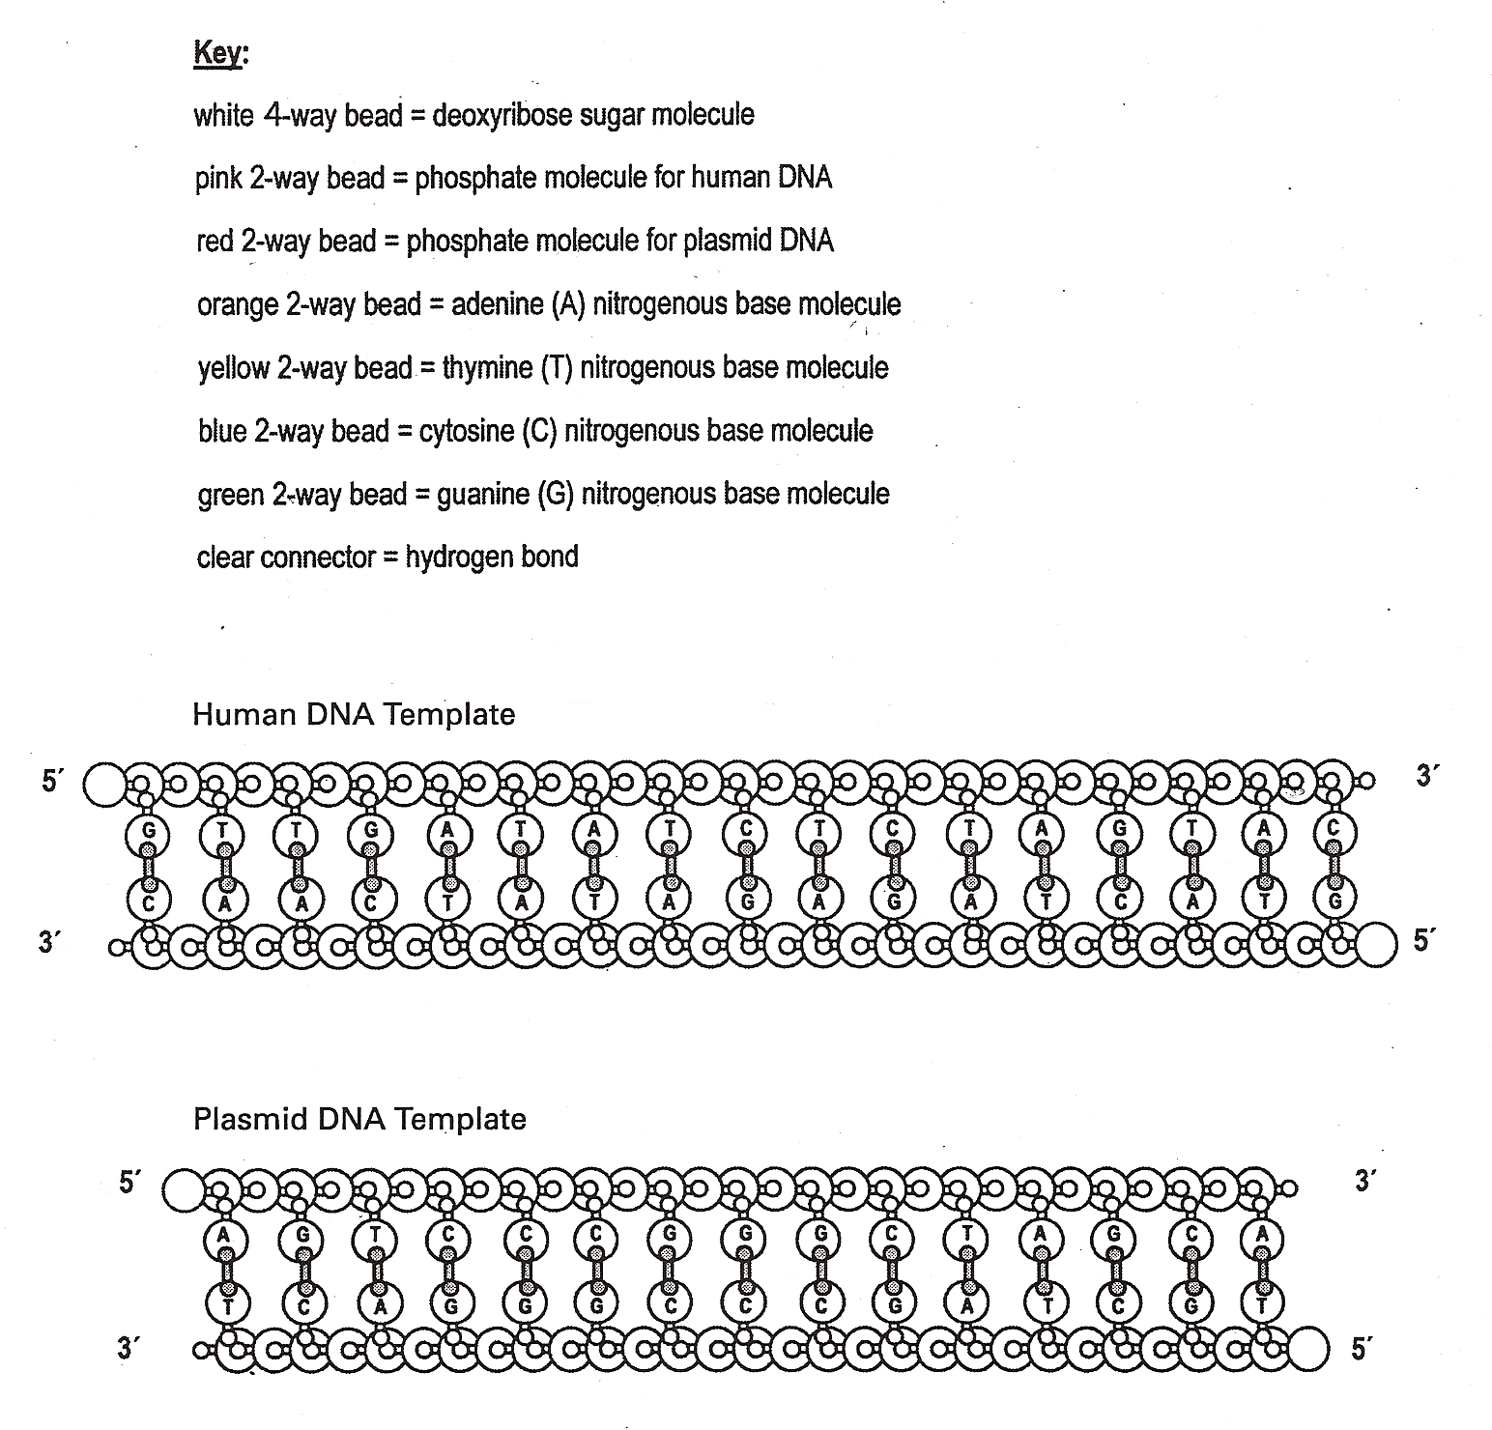

Questions

- What does it mean to clone a gene using recombinant DNA technology?

- State three reasons why restriction enzymes are such a useful tool in genetic engineering.

- Determine whether or not the following DNA fragment ends can be ligated.

a. 5’-TCAGGATC CGGT-3’ b. 5’-ACTTAAT TAAGG-3’
3’-AGTC ATAGGCCA-5’ 3’-TGAAT TAATTCC-5’

c. 5’-TTGG TAAAG-3’ d. 5’-TAT CGGATGT-3’
3’-AACC ATTTC-5’ 3’-ATAGC TACA-5’

- Why is it desirable to produce human insulin through recombinant DNA technology?

Extension
When DNA fragments cut by the same enzyme are ligated, their union recreates the recognition site for that enzyme. This makes the new recombinant molecule susceptible to cleavage by that enzyme. However, when DNA fragments cut by different enzymes are ligated, neither enzyme recognition site is recreated and neither enzyme can cleave the new molecule at that site. Flip the recombinant DNA plasmid molecule over so that the twist tie is once again on top. In order to create this molecule you used the restriction enzymes EcoRV, SmaI, and BfaI. Rotate the plasmid in your hands and scan the DNA for their recognition sequences.
- Did you find a recognition sequence for EcoRV, SmaI, or BfaI?

- What happened to the restriction enzyme site when the blunt ends created by the EcoRV and SmaI enzymes were joined and when the cohesive ends created by BfaI were joined?

- If you wanted to remove the human insulin gene from the plasmid and clone it into a different plasmid could it be done? Explain.

- What are the advantages and disadvantages of blunt-cut enzymes versus staggered-cut enzymes?

