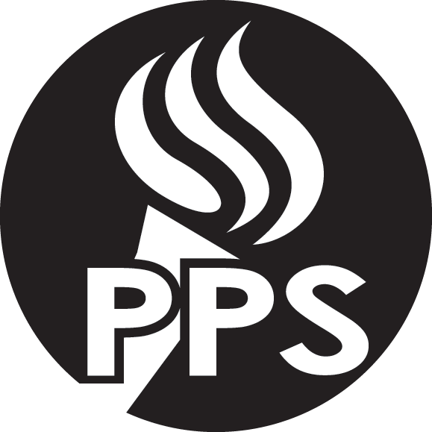
August 2016

Coming home soon with your student:
2016-17 Student Responsibilities, Rights and Discipline Handbook

Portland Public Schools is pleased to announce the distribution of the 2016-17 Student Responsibilities, Rights, and Discipline Handbook. This Handbook provides information on the PPS's efforts to create safe and supportive school climates for each student.

Your student will be bringing home the updated Handbook in the next few days. Please take some time together to review the information. If you need a copy in Spanish, Vietnamese, Chinese, Russian or Somali or you have questions, please contact your school's office.

Improving Discipline Practices Among Top Priorities
For 2016-17 the PPS School Board established the priority to create a system of behavior supports that will reduce disproportionality of Historically Underserved students in expulsions and suspensions.

The 2016-17 Handbook update is just the beginning of a shift toward ensuring that we are providing consistent interventions, supports and consequences for all students while ensuring equitable outcomes and safe schools.

Goal of Updated Handbook
The 2016-15 Handbook provides more options for principals to promote both safety and learning to keep students at school learning academic and social skills.

The District's goal is to work alongside families in addressing student conduct. Joining with families at the earliest sign of concern can improve student learning and prevent or resolve issues that can otherwise lead to exclusionary discipline.

More information
Families are welcomed and encouraged to contact their student’s teachers or principal with any concerns or questions. Additional questions can be directed to Rick Kirschmann, Asst. Director for School Climate and Discipline, PPS Office of Equity & Partnerships, rkirschmann@pps.net or 503-916-3121.

