TITLE OF EVENT:

Alpha School’s Back-to-School Picnic

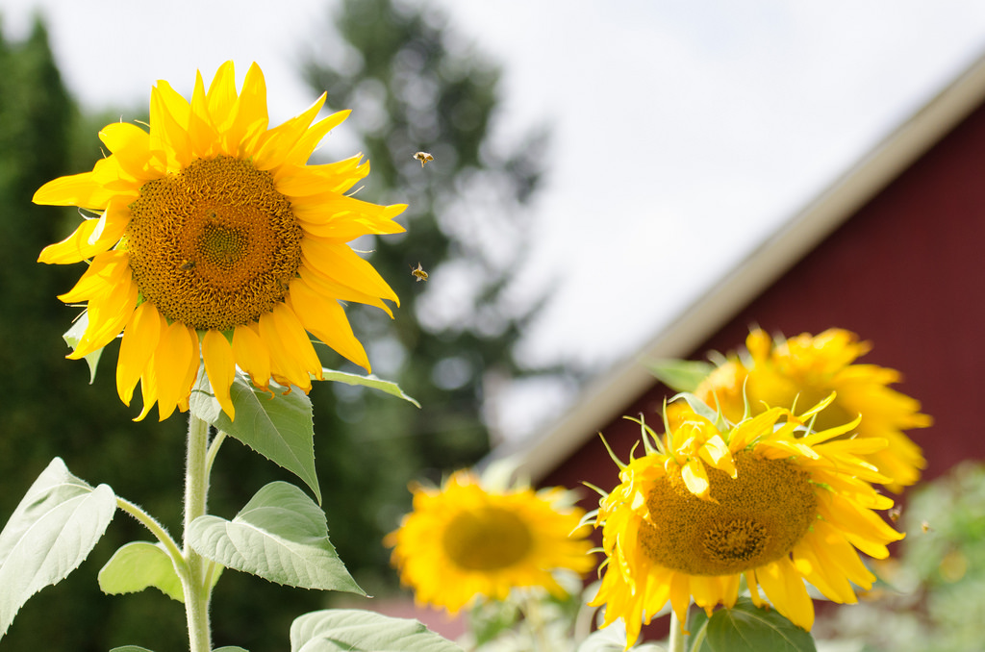

Date/Time/Location:

Tuesday, Sept. 15 at 6 pm

Our School

Our School’s Address

Details: (For example: Bring a picnic or purchase burritos at the event for $5.)

More information: website, contact name, email/phone