TITLE OF EVENT:

Alpha School’s Gardening Day

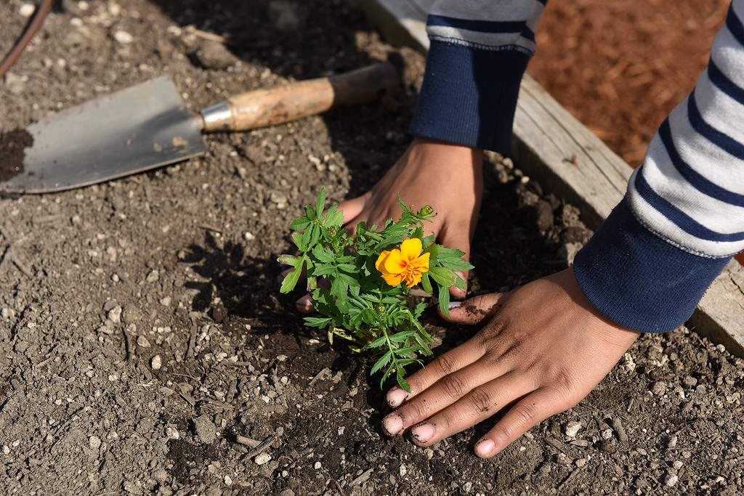

Date/Time/Location:

Saturday, Sept. 12 at 10 am to 1 pm

Our School

Our School’s Address

Details: (For example: Bring shovels and gloves and help us plant flowers and vegetables in our school garden.)

More information: website, contact name, email/phone