TITLE OF EVENT:

Multicultural Night at Alpha School

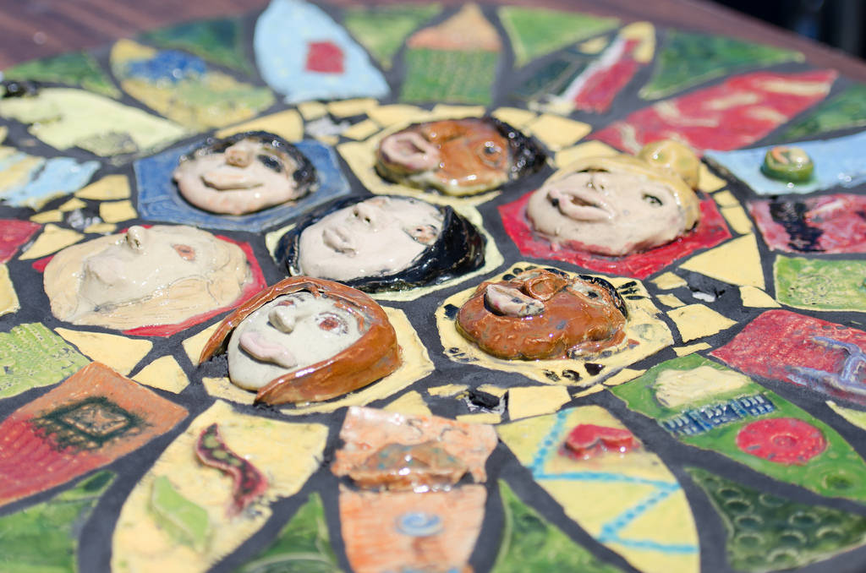

Date/Time/Location:

Friday, Sept. 4 from 7 pm to 9 pm

Alpha School Gym

Our School’s Address

Details: (For example: Come sample food and make crafts from many of the cultures represented at our school.)

More information: website, contact name, email/phone